Unit 6. Lesson 4. Hats and bats |  | School: #
Date: |  | Surname /name of the teacher:
Group: |  | Number of attendees: ____ | Number of absent learners: ____
Aims of the lesson: | 0.L3 begin to recognize with considerable support simple greetings  0.L1 begin to recognize simple short instructions for the basic classroom routine spoken slowly and distinctly

0.L5 begin to recognize simple sounds of phonemes
0.S3 pronounce the basic words and expressions with some mistakes
Objectives of the  Lesson |  | The learners will be able to:
- recognize and exchange with some considerable support simple greetings • recognize and carry out simple short instructions for the basic classroom routine spoken slowly and distinctly
- recognize simple sounds of phonemes
 |  | The majority of the learners will be able to:
- recognize and exchange simple greetings
- recognize and carry out simple short instructions for basic classroom routines .recognize simple sounds of phonemes
 |  | Some of the learners will be able to:
 |  | • say the topic vocabulary without difficulties and mistakes.
Background knowledge |  | This is the final lesson of the unit, so the children know and recognize topic vocabulary, numbers and colours.
Plan
Scheduled time | Scheduled activity |  | Resources
Beginning of the lesson  5 minutes | • Warm up:  To warm up the students ask them to talk about their favourite holiday. Encourage them to exchange their ideas.  Then suggest them playing the game “Presents”. You need a box and some toys. Show them a box with toys. Children should name the toys, e.g.: a car, a cat, a teddy, a dog, a bus, a monkey, etc. then ask the children to close their eyes and addone more toy. Children should say which toy was added.  Make them name all the toys and the new one. 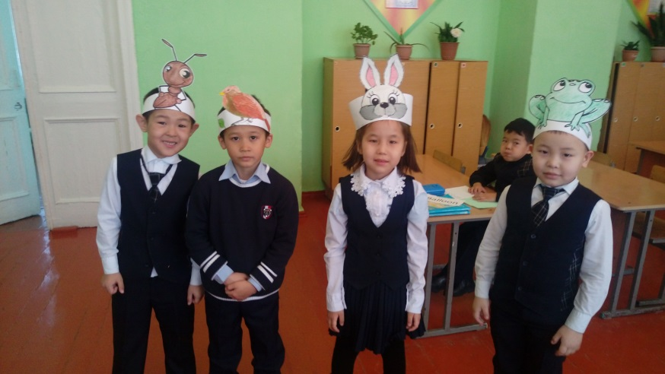
Main part of the lesson | them and ask them to say the words and carry out the actions in the given order: to inflate a balloon, to eat a cake, to open a present, to blow out a candle. Then show the cards and say the words with the children not in the given order, e.g.: to open a present, to eat a cake, to inflate a balloon, to blow out a candle. 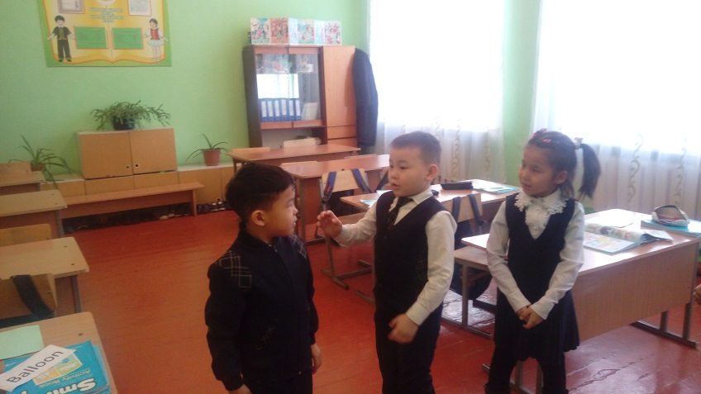  Then direct the children’s attention to the pictures of exercise 1 on page 50. Tell the students to name the objects they see.  Exercise 2. Look at the pictures, listen and learn.  Ask the learners to follow the pictures, listen to the audio and repeat. Pause after each picture to let the children repeat. Make sure they understand everything.  Exercise 3.Name the object.  Ask the students to look at the puzzles, guess and name the objects.  Students’ answers:  A candle, a balloon, a present, a cake  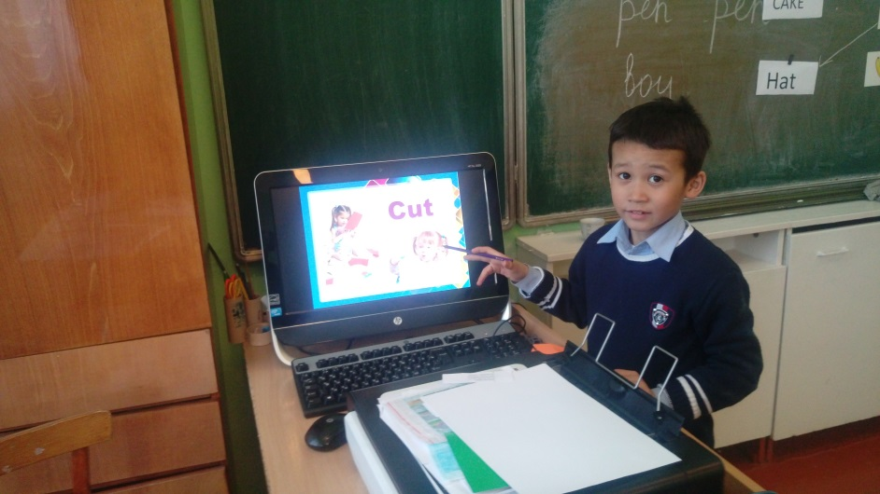.

End  5 min | Reflection / home task  Ask sts to look at the ladder of success and identify their position at the end of the lesson (with great teacher support)  Give home task: to learn the words on the topic “Birthday” |  |  | A picture of a ladder of success
Additional information
Differentiation – how do you plan to give more support? How do you plan to challenge the more able learners? |  | Assessment – how are you planning to check learners’ learning? | Health and safety check  ICT links
Less able students – greater support by means of visuals or writing difficult words on the blackboard  More able students – independent work on definite tasks with little/no support |  | - Monitor individual / group work, listen to discussions, check sts’ understanding of classroom instructions  - Consider results of self-assessment and peer assessment | - Use water based markers  - Work with the SMART board not more than 10 minutes. Make short breaks.  - Ensure proper ventilation  - Monitor classroom space when sts start moving around  - Check sockets’ safety
Reflection
Were the lesson objectives/learning objectives realistic? Did all learners achieve the LO? If not, why?
Did my planned differentiation work well?
Did I stick to timings?
What changes did I make from my plan and why?
Summary evaluation
What two things went really well (consider both teaching and learning)?
1: 2:
What two things would have improved the lesson (consider both teaching and learning)?
1: 2:

What have I learned from this lesson about the class or achievements/difficulties of individuals that will inform my next lesson?

